**How To Create An Aggregate Package:**

1. **(L) Click** & **drag** the **Source Assistant** to the **package window** from the **Data Flow toolbox panel**.

2. Select **Source type**: **Select SQL Server**

1. Select **Connection Managers**

1. Select a **"New"** connection or **select** the **designated (1)** that you created. However, if you have to **select** a **"New"** connection, then once the **Connection Manager** box appears, then make sure for both the **"Server Name"** & the **"Authentication"** is the same that you use for **SSMS**, because **sometimes** the **drop down link doesn't work**. **Note: Never** change the **"Provider"** from the **standard** **"Native OLE DB\SQL Server Native client 11.0”**, **unless** you have a reason for changing it.

2. Click **OK** & your **OLE DB Source** will appear in the **"package window".** **Note: Data Flow** uses **Components** & the **Control Flow** uses **Tasks**.

1. **Repeat** the **same steps** above **in 1, 2.** a) **1 & 2** for the **Destination Assistant Component.**

3. **(L) Click** & **drag** the **Aggregate Component** to the **package window** from the **Data Flow toolbox panel** and place it underneath the **OLE DB Source** & between both the **OLE DB Source** and the **OLE DB Destination.**

3. **(L) Click** the **OLE DB Source** & **connect** the **blue arrow** from the **OLE DB Source** to the **Aggregate Component**

4. How to **remove** the **red (X)** from the **Aggregate Component.** **Error message:** **Select** at least **(1) column** for the **current aggregation.**

1. **Double click** the **Aggregate Component** package again (**without** clicking the name) or **(R) click** the **Aggregate Component** package and **select** edit. When the **Aggregate Transformation editor** page appears, **select** your specific **Input Column**, **Output Alias** & **Operation** then **click OK** & the **red (X)** would **disappear**. For **example**: 1st column) **Input Column = SalesPerson,** Output Alias = SalesPerson, **Operation = Group By** • 2nd column) Input Column = (*), **Output Alias = Count All,** Operation = Count All.
2. **(L) Click** & **drag** the **OLE DB Destination** to the **package window** from the **Data Flow toolbox panel** and **place** it **underneath** the **Aggregate Component**. **How** to **remove** the **red (X)** from the **OLE DB Destination. Error message:** **Map** the **columns** on the **"Mappings"** page.
3. **Double** click the **OLE DB Destination package** again **(without clicking the name)** or **(R) click** the **OLE DB Destination package** and select **edit.** **When** the **OLE DB Destination editor page** appears, **another Error message** appears and states **"Map the columns on the "Mappings" page".** **So,** click **"OLE DB connection manager"** drop **down link** & **select** your **connection manager info:** For Example: **THEMCCOYS\SQLEXPRESS.SSIS** • Click **"Data access Mode"** drop **down link** & select **Table or view- fast load:** • **Then** click **"Name of the table or the view"** drop **down link** & **select** your **specific table.** For example **[dbo].[Output03]:** • Then **click** on **"Mapping"** in your **left hand** column & **Map** both the **Input Column** & **Destination Column** together. Ex: **1st column) Input Column = SalesPerson** & Count All • **2nd column) Destination Column = SalesPerson** & SalesPerson Count, **then** click **OK** & the **red (X)** would **disappear.**

**T-SQL Example for query below:**

|  |  |  |  |  |  |  |  |  |  |  |  |  |  |  |  |  |  |  |  |  |  |  |  |  |  |  |  |  |  |  |  |  |  |  |  |  |  |  |  |  |  |  |  |  |  |  |  |  |  |  |  |
| --- | --- | --- | --- | --- | --- | --- | --- | --- | --- | --- | --- | --- | --- | --- | --- | --- | --- | --- | --- | --- | --- | --- | --- | --- | --- | --- | --- | --- | --- | --- | --- | --- | --- | --- | --- | --- | --- | --- | --- | --- | --- | --- | --- | --- | --- | --- | --- | --- | --- | --- | --- |
| SELECT  *  FROM  Output03 | |  |  |  |  |  | | --- | --- | --- | --- | --- | | ID | Status | SalesPersonCount | — | — | | 1 | adventure-works\jae0 | 78 | — | — | | 2 | adventure-works\jillian0 | 148 | — | — | | 3 | adventure-works\shu0 | 151 | — | — | | 4 | adventure-works\garrett1 | 78 | — | — | | 5 | adventure-works\linda3 | 71 | — | — | | 6 | adventure-works\david8 | 73 | — | — | | 7 | adventure-works\pamela0 | 74 | — | — | | 8 | adventure-works\michael9 | 32 | — | — | | 9 | adventure-works\josé1 | 142 | — | — | |

**Image:**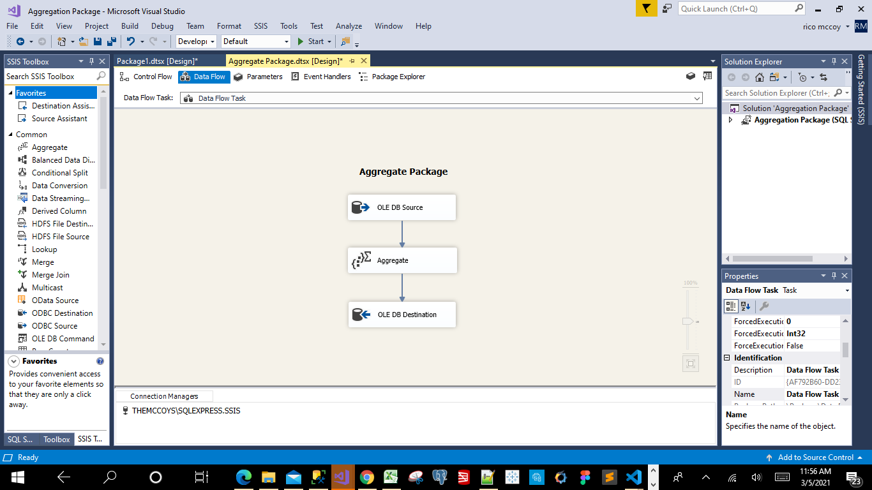

**After running the Aggregation Package w-Data Viewer Screen Shot:** 